**Lab Sheet - Set Associative Cache**

**Objectives**

At the end of this lab session student should be able to:

* Understand set associative mapped cache
* Understand the behavior of set associative mapped cache by varying block size, cache size and number of sets
* Understand the behavior of fully associative mapped cache with reference to replacement algorithms

**Prerequisites:** Module No. 4 - Cache Memory Organization

**Contents:**

Performance analysis of Set Associative Mapped Cache

7.1 Effect of cache size on the performance of Set Associative Mapped Cache

7.2 Effect of block size on the performance of Set Associative Mapped Cache

7.3 Effect of number of sets on the performance of Set Associative Mapped Cache

7.4 Performance analysis of Set Associative Mapped Cache with various replacement algorithms

**7.0 Performance analysis of Set Associative Mapped Cache**

The following program should be used for the analysis of set associative mapped cache.

LDB 00, R00

LDB 16, R01

LDB 32, R02

LDB 00, R03

LDB 16, R04

LDB 20, R05

LDB 24, R06

LDB 00, R07

LDB 20, R08

LDB 28, R09

HLT

Press “Cache-Pipeline” tab and select cache type as “data cache” as shown in Figure 1. Press “Show Cache..” button. A new window will be opened which is as shown in Figure 2.

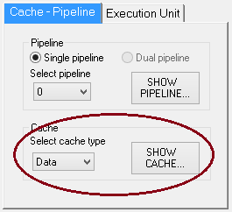

**Figure 1: Cache – Pipeline setting**

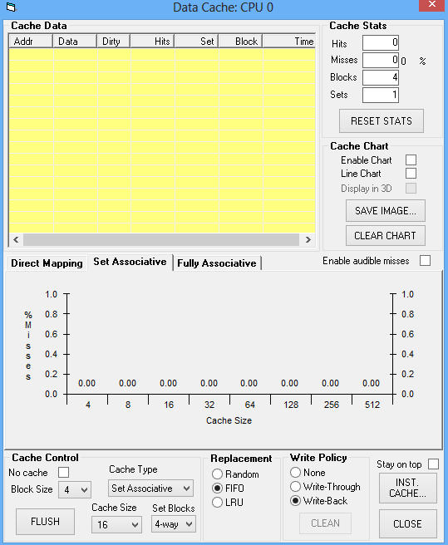

Figure 2: Data cache window

**7.1 Effect of cache size on the performance of Set Associative Mapped Cache**

Step 1: Set the following parameters available in cache control block of data cache window as shown in Figure 2.

* Cache Type : Set Associative
* Number of sets (Set Blocks ) : 2 way
* Block Size : 4
* Select Enable Chart check box
* Select stay on top check box
* Replacement: LRU

Step 2: Run the program in single step and observe the changes on the data cache window

Step 3: Fill in the following table with number of hits, misses and hit ratio with different cache sizes (8, 16, 32, and 64)

|  |  |  |  |  |
| --- | --- | --- | --- | --- |
|  | Cache size = 8 | Cache size = 16 | Cache size = 32 | Cache size = 64 |
| Number of hit | 0 | 1 | 2 | 4 |
| Number of miss | 10 | 9 | 8 | 6 |
| Hit ratio | 0 | 0.1 | 0.2 | 0.4 |

Step 4 : Plot the graph of cache size vs hit ratio and comment on the results obtained.

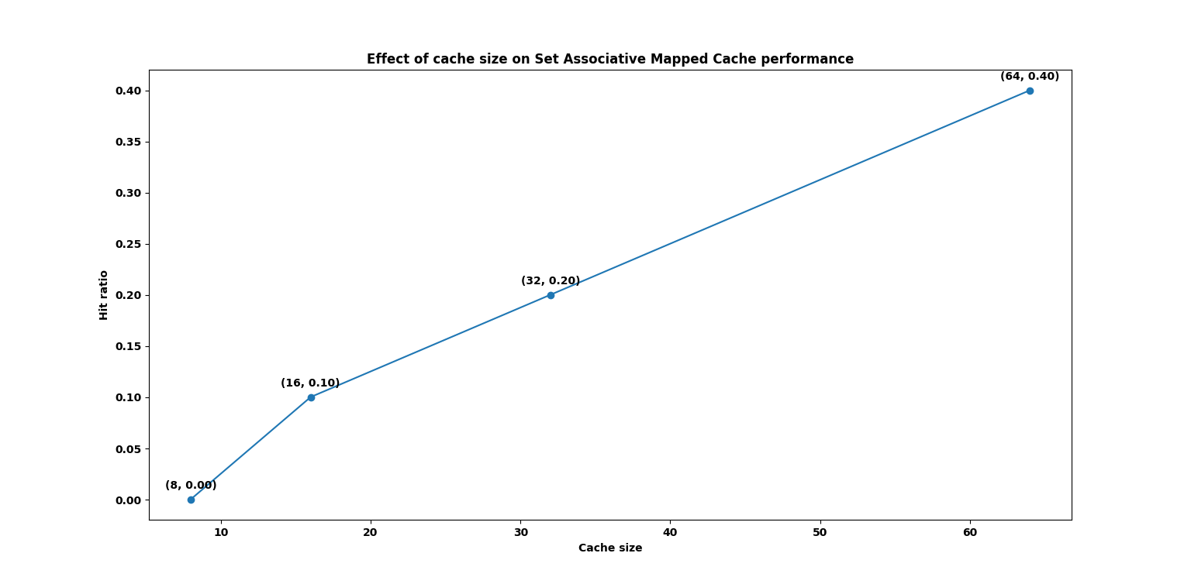

Based on the table and graph of cache size vs hit ratio, it is clear that increasing the cache size leads to a significant improvement in cache performance. As the cache size increases from 8 to 64, the number of hits increases from 0 to 4, and the hit ratio increases from 0 to 0.4. This suggests that larger caches are more effective at reducing cache misses and improving the overall performance of the Set Associative Mapped Cache.

However, it is worth noting that the improvement in hit ratio seems to level off beyond a cache size of 32, suggesting that there may be diminishing returns to further increasing the cache size beyond this point. Additionally, while the experiment provides valuable insights into the effect of cache size on cache performance, it is important to keep in mind that the results may be specific to the particular parameters and conditions used in the experiment, and may not necessarily generalize to other settings.

Overall, the results obtained from the experiment suggest that cache size is an important factor to consider in optimizing the performance of a Set Associative Mapped Cache, and that larger cache sizes can significantly improve cache performance.

**7.2 Effect of block size on the performance of Set Associative Mapped Cache**

Step 1: Set the following parameters:

* Cache Type : Set Associative
* Cache Size : 32 bytes
* Set blocks : 2 way
* Select Enable Chart check box
* Select stay on top check box
* Replacement algorithm : LRU

Step 2: Execute the above program by setting block size to 2, 4, 8, 16 and 32. Record the observation in the following table.

|  |  |  |  |
| --- | --- | --- | --- |
| Block Size | Miss | Hit | Miss ratio |
| 2 | 8 | 2 | 0.8 |
| 4 | 8 | 2 | 0.8 |
| 8 | 6 | 4 | 0.6 |
| 16 | 5 | 5 | 0.5 |
| 32 (Cache Size : 64) | 2 | 8 | 0.2 |

Step 3: Plot the graph of Cache miss ratio Vs Block size

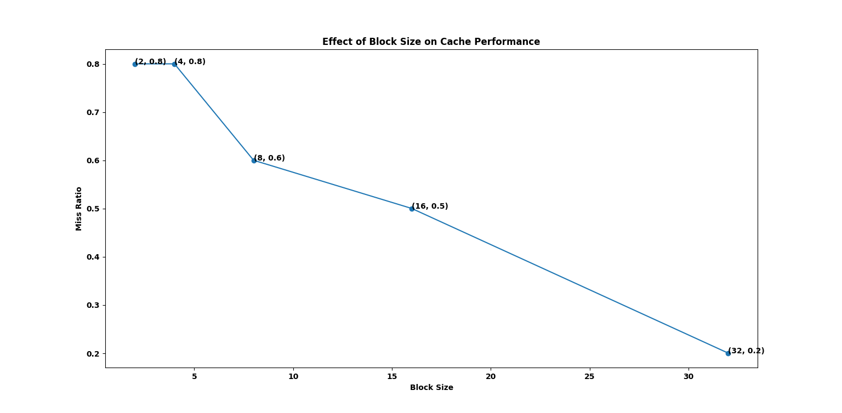

**7.3 Effect of number of sets on the performance of Set Associative Mapped Cache**

Step 1: Set the following parameters:

* Block size : 4
* Cache size : 32
* Cache Type : Set associative cache
* Select Enable Chart check box
* Select stay on top check box
* Replacement: LRU

Step 2: Execute the above program by setting set blocks to 2 way, 4 way and 8way. Record the observation in the following table.

|  |  |  |  |
| --- | --- | --- | --- |
| Set Blocks | Miss | Hit | Hit ratio |
| 2 | 8 | 2 | 0.2 |
| 4 | 6 | 4 | 0.4 |
| 8 | 6 | 4 | 0.4 |

Step 3: Plot the graph of Cache hit ratio Vs Set block size.

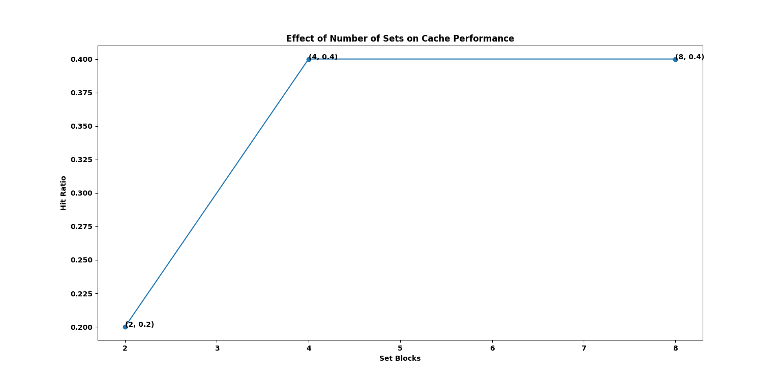

**7.4 Performance analysis of Set Associative Mapped Cache with various replacement algorithms**

Step 1 Set the following parameters:

* Block size : 4
* Cache size : 32
* Set blocks : 2 way
* Select Enable Chart check box
* Select stay on top check box

Step 2: Execute the above program by setting replacement algorithm as FIFO, Random and LRU. Record the observation in the following table.

|  |  |  |  |
| --- | --- | --- | --- |
| Replacement Algorithm | Miss | Hit | Miss ratio |
| FIFO | 8 | 2 | 0.8 |
| LRU | 8 | 2 | 0.8 |
| Random | 63 | 17 | 0.787 |